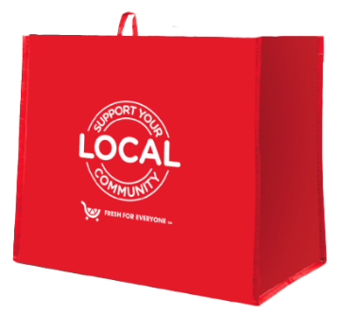

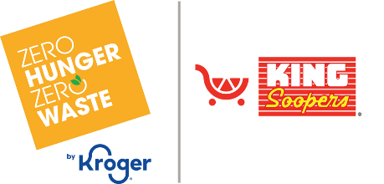

Thank Your Supporters Email

SUBJECT: Because of you, we made an impact.
PREVIEW TEXT: Your support helped turn everyday shopping into meaningful change.

Good morning,

We’re thrilled to share that [name of organization] will receive $[donation amount] from our partnership with the Kroger Fight Hunger bag program during [month 1 and month 2].

This impact is because of you. Whether you purchased a bag or helped spread the word,
you played a part in making this program a success. Together, we turned small, everyday actions
into real support for our mission.

These funds will help us to [share what you’ll do with the donations], bringing meaningful change to those we serve.

Thank you for showing what a community can do when it comes together!

With gratitude,
[Signature]

