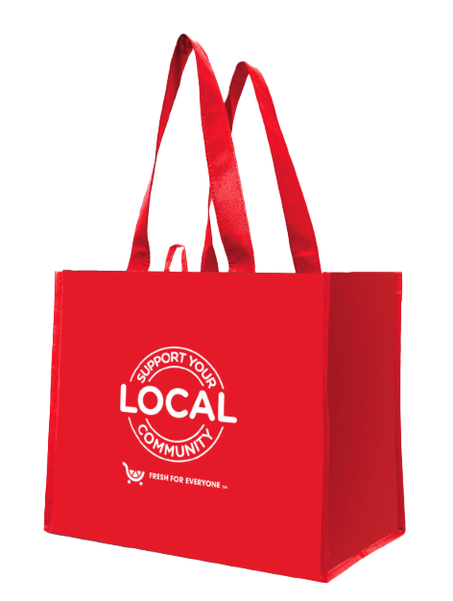

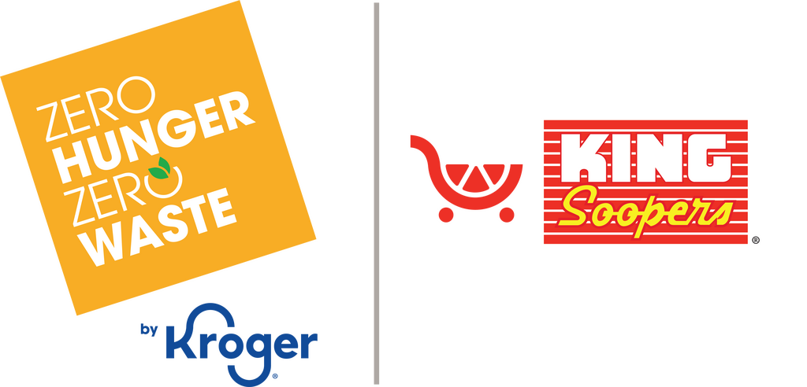

Reminder Email

SUBJECT: We’re almost halfway there; let’s keep the momentum going!
PREVIEW TEXT: There’s still time to make an even bigger impact for our community.

Good morning,

We’re approaching the halfway point of our two-month partnership with the King Soopers
Fight Hunger bag program. Now is the time to keep the momentum strong.
For every $2.50 reusable Fight Hunger bag purchased at [insert location(s)] during [month 1 and month 2], $1 is donated directly to support our mission. Each bag purchase represents a simple action with real impact, sparking positive change in our community and helping feed those in need.
There’s still time to grow what we’ve started!

Please help us spread the word. Share with your friends, family, and community, and
remind them to look for Fight Hunger bags in our selected store(s).

Together, we can turn a simple bag purchase into meaningful support.

Thank you for being part of this effort.

Gratefully,
[Signature]

