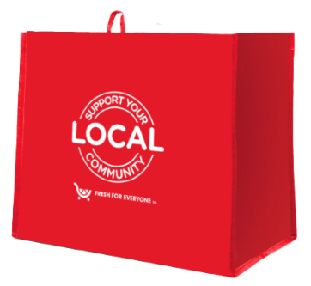
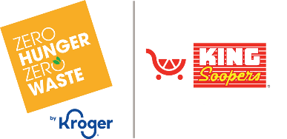

Launch Day Email

SUBJECT: It starts today! Help us make a difference, one Fight Hunger bag at a time.
PREVIEW TEXT: Every bag purchased supports our mission in a meaningful way.

Good morning,

Today marks the beginning of something meaningful. We’re excited to partner with the
King Soopers Fight Hunger bag program, and starting today, you have a simple way to help
make a real difference.
Throughout [month 1 and month 2], every $2.50 reusable Fight Hunger bag purchased at the
King Soopers located at [address(es) of selected store(s)] will provide a $1 donation to [name of organization]. Each bag may seem small, but together they add up to something powerful.
We’ve set a goal to raise $[total], and with your support, we know it’s possible.
You can help today by:

- Choosing a Fight Hunger bag at our selected King Soopers when you’re shopping.
- Sharing this opportunity with your friends and family.
- Encouraging others to support while they shop.

Because of you, more individuals and families will have access to the resources they need.
Thank you for standing with us, and for helping turn everyday choices into meaningful impact.

Gratefully,
[Signature]

