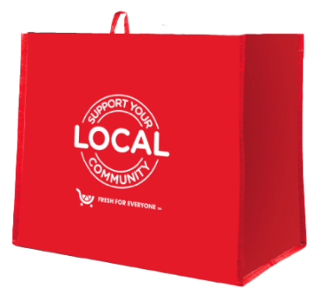
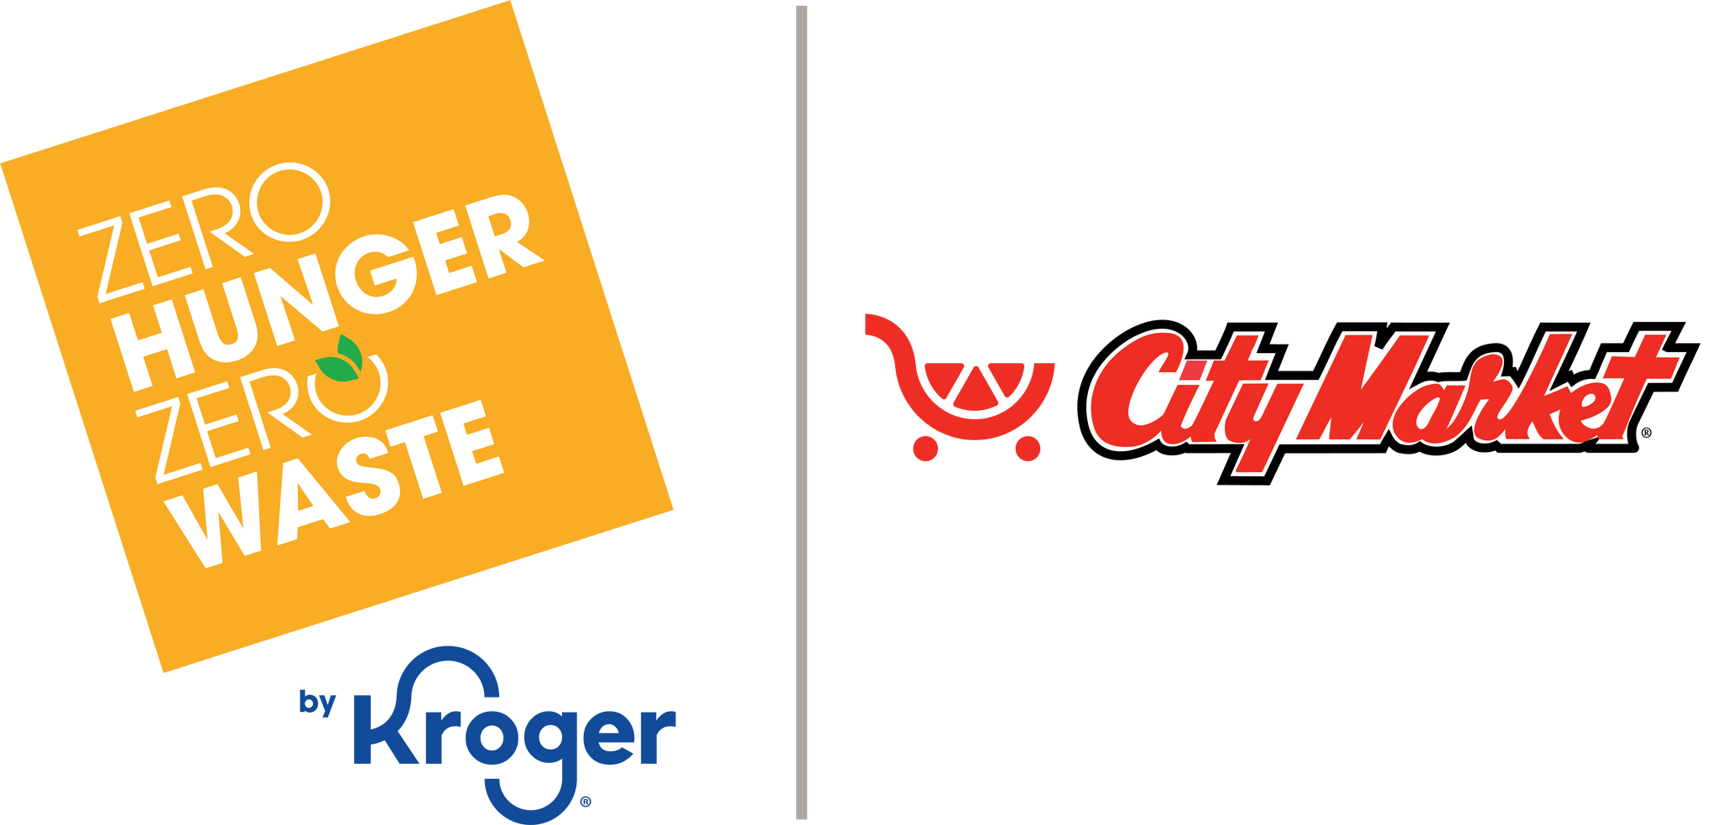

Announcement Email

SUBJECT LINE: We’ve been selected to partner with the City Market Fight Hunger bag program!
PREVIEW TEXT: Every Fight Hunger bag sold at our selected City Market location(s) during [month 1 & month 2] = $1 for [organization].

Dear [Staff/Board/Volunteers/Supporters],

We’re excited to share that City Market has selected [organization] to benefit from the Fight Hunger bag program during [month 1 and month 2]! This program, aligned with the City Market
Zero Hunger | Zero Waste initiative— aimed at helping to end hunger and eliminate waste in local communities—makes it easy to give back while you shop.

Here’s how it works:
For every $2.50 reusable Fight Hunger bag purchased at:
[store address(es)]
$1 is donated to [organization].

It’s that simple, and it adds up fast. Each bag purchased is a small action that helps us continue to [brief mission impact, e.g., “provide meals,” “support families,” “serve our community”].

If you’re able, please help spread the word:

- Share with friends and family.
- Post on social media.
- Mention it the next time you connect with someone.

The more bags purchased, the greater the impact we can make together. Thank you for helping turn everyday shopping into meaningful support for our mission!

With gratitude,
[Signature]

